CSC231: Object Oriented Programming (1)

Final Project Report Template
Project Group Number (As In Blackboard): Group 2
Section Number: 4MI03
Project Title: Car Rental System

Members:

 | Name | ID
1 | Abdullah Saleh Alfozan (Leader) | 2240005796
2 | Mohammed Waleed Jaafar | 2240004104
3 | Khaled Mohammed Alatrash | 2240006439
4 | Shabeb Khaled Althori | 2240007357

Difficulties & How Problems Were Solved:

- Problem: Database File Not Found or Not Created

Difficulty:
When running the application, the SQLite database file (car_rental.db) was sometimes not created in the expected directory, leading to connection errors.

Solution:
I used the DBHelper class to print the absolute path of the database:

This helped me ensure the file was created in the correct location and debug any path issues.

- Problem: SQL Exceptions When Adding Duplicate Customers

Difficulty:
Trying to register a user with a username that already exists caused an SQL exception.

Solution:
In CustomerDAO.register, I caught the SQLException and returned false, which the UI interprets as a duplicate:

This prevented the program from crashing and allowed for a user-friendly error message.

- Problem: Not Closing Database Resources Properly

Difficulty:
Forgetting to close JDBC resources (like Connection, Statement, ResultSet) could lead to resource leaks.

Solution:
I used Java’s try-with-resources statement:
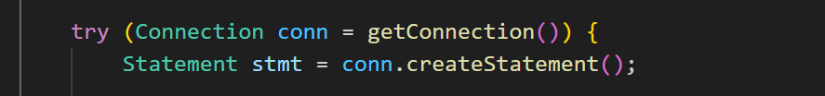
This ensures all resources are closed automatically when done.

- Problem: Incorrect SQL Queries

Difficulty:
Syntax errors replace the SQL statement, which means that the column names have been typed incorrectly or required parameters were left out, which meant that the program was errorsome or the information was not found.

Solution:
I rechecked the SQL queries compatible with the DBHelper table definitions. For instance, there is a match between insert and select statement such that the columns and the data type of the table was well maintained.

Checklist Of Requirements Fulfilled In The Project:

Function / Application Aspect | UML Diagrams | Classes Management | Inheritance & Polymorphism | ArrayList | Array Of Objects | Program Structure | Error Handling | Analysis
Car Rental System Main Function |  |  | ꓫ |  | ꓫ |  |  | 
Login and Registration |  |  | ꓫ |  | ꓫ |  |  | 
Admin Management |  |  | ꓫ |  | ꓫ |  |  | 
Company/Car Management |  |  | ꓫ |  | ꓫ |  |  | 
Operations (Cars/Customers) | ꓫ |  | ꓫ |  | ꓫ |  |  | 
Database Integration | ꓫ |  | ꓫ |  | ꓫ |  |  | 
Logging and Audit Trail | ꓫ |  | ꓫ |  | ꓫ |  |  | 
Swing GUI Interface | ꓫ |  | ꓫ |  | ꓫ |  |  | 
User Input Validation | ꓫ |  | ꓫ |  | ꓫ |  |  | 
Report Generation (Logs View) | ꓫ |  | ꓫ |  | ꓫ |  |  | 

How Were The Tasks Distributed Equally Between Members?

The tasks in the project were distributed equally among all members by assigning each member a clear and distinct responsibility that contributed to the overall completion of the Car Rental System. Each task was chosen based on project needs and was designed to ensure that every member had a meaningful and essential role:

1. Abdullah Saleh Alfozan (Leader) completed the majority of the technical tasks, including database schema design & deployment, JDBC integration, & project workflow organization in general.

2. Mohammed Waleed Jaafar performed the primary login and registration GUI development with Java Swing, a critical component of the user experience.

3. Khaled Mohammed Alatrash focused on the admin dashboard GUI and user management interface development, encompassing both interface and user operations.

4. Shabeb Khaled Althori worked on the company and customer dashboard GUIs, car listing and booking, addressing the main business features.

5. Hamzah Ahmed Alturaiki was involved in the project documentation and user guide, making sure all was clear from the technical as well as the user point of view.

6. Mohammed Ali Albajhan's role in bug reporting and software testing is a very crucial role, where he was responsible for maintaining quality levels of application.

7. Ali Saeed Almuhr designed the project logo and assisted with end report formatting, which supported the presentation and professionalism of the project.

By dividing the work in this way, each member was assigned a specific area of the project, leading to a fair and balanced distribution of tasks and responsibilities.

General Comments:

Comprehensive Functionality:
Users can access the entire car rental system functionality starting from registration and ending with login, managing cars, bookings and administrative duties.

Good Use of Java Concepts:
The program shows advanced proficiency in Java programming basics along with proper implementation of classes and ArrayLists as well as error handling and JDBC for database connection.

User-Friendly Interface:
The application delivers an intuitive graphical user interface with Java Swing components to serve both end-users and administrators equally well.

Clear Separation of Concerns:
The project organization consists of distinct classes for database operations (DAOs), GUI, and business logic thus providing better maintability and organization.

Effective Error Handling:
The application uses proper error handling mechanisms for improper inputs, database and file operation errors that produces a more reliable system.

Documentation and Reporting:
The system features both documentation and user manuals that help users learn system operation and maintain developers' ability to support the codebase.

The Updated UML DIAGRAM:
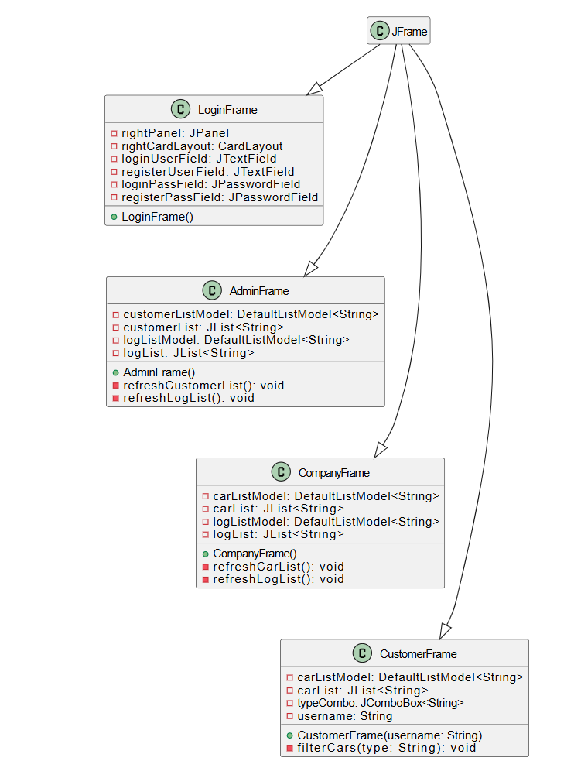

Project Details:

1. Startup & Main Menu
- Description: The application starts with the login/register window.
- Features:
  - Choose to log in as Customer, Admin, or Company.
  - Register a new user.
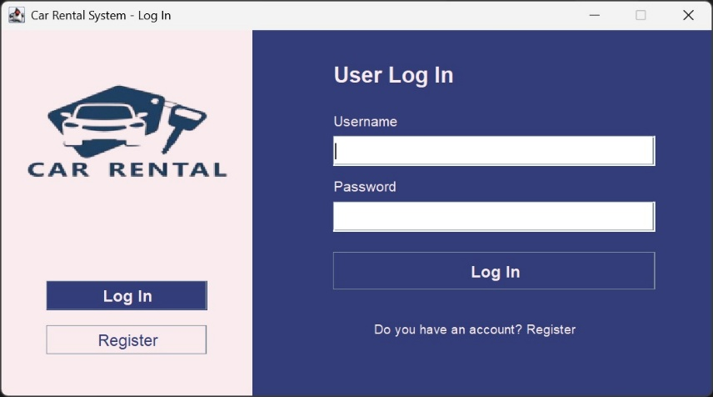
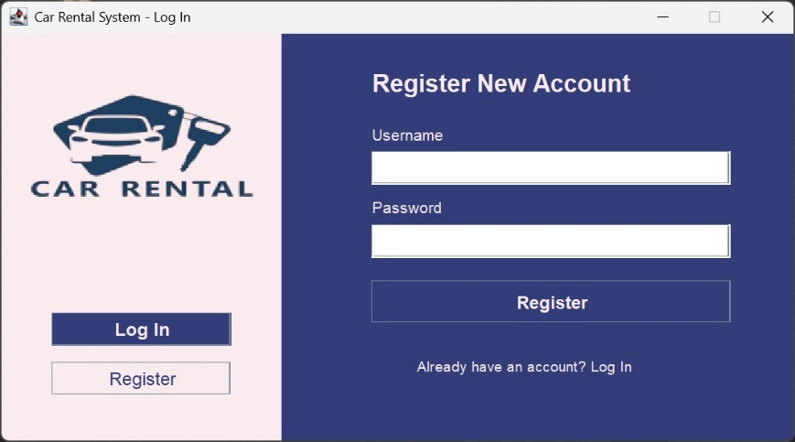

2. User Registration
- Description: New users can create an account by entering their details.
- Features:
  - Username and password entry.
  - Validation for duplicate usernames and empty fields.

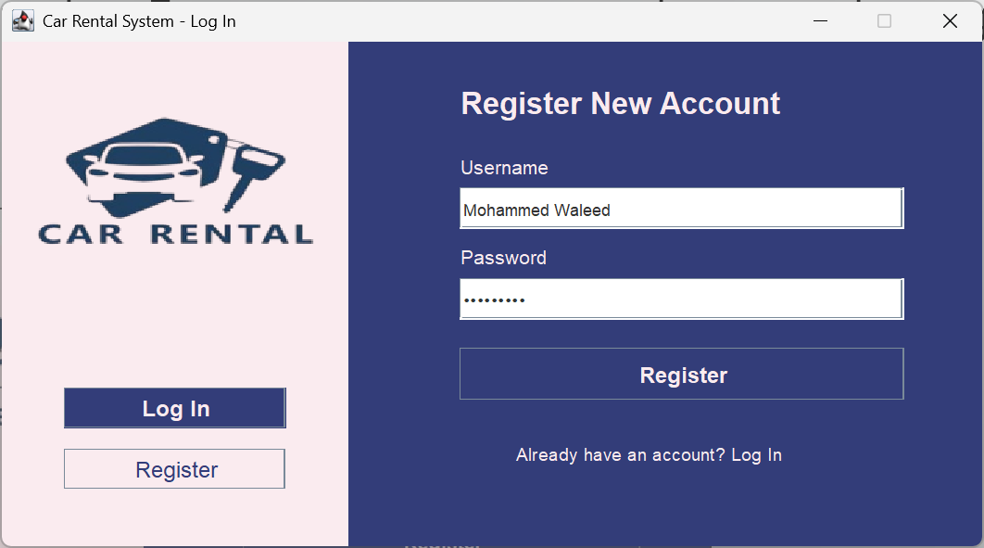

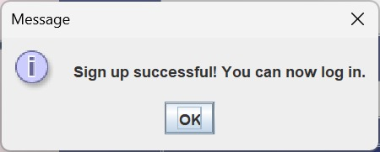

3. User Login
- Description: Existing users log in with their credentials.
- Features:
  - Username and password fields.
  - Error message for invalid login.

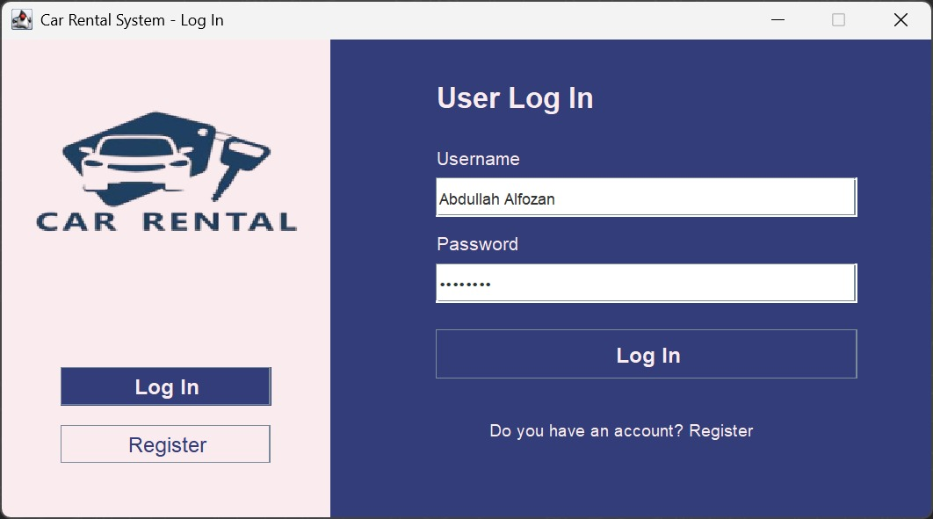

4. Admin Dashboard
- Description: Accessible by admin users after login.
- Features:
  - View all customers.
  - Add/edit/delete customer accounts.
  - View system logs/history.
  - Manage all users.
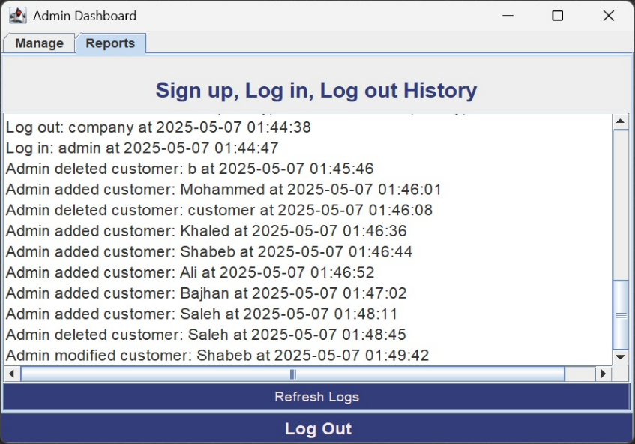
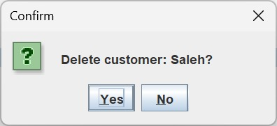
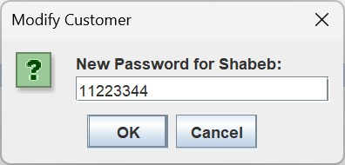
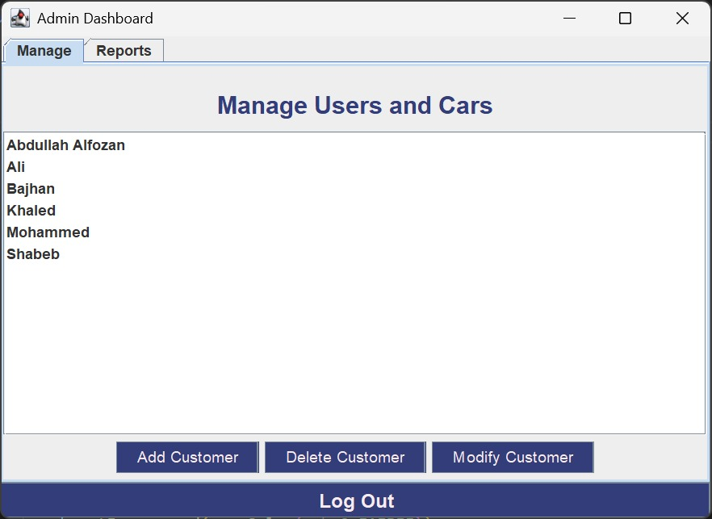
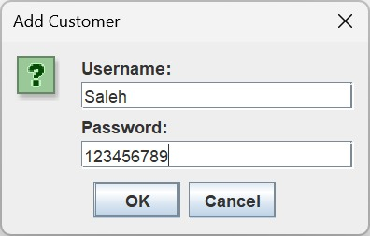

5. Company Dashboard
- Description: Accessible by company users after login.
- Features:
  - Add new cars to the system.
  - Edit or delete car information.
  - View all cars managed by the company.
  - See car rental logs/history.

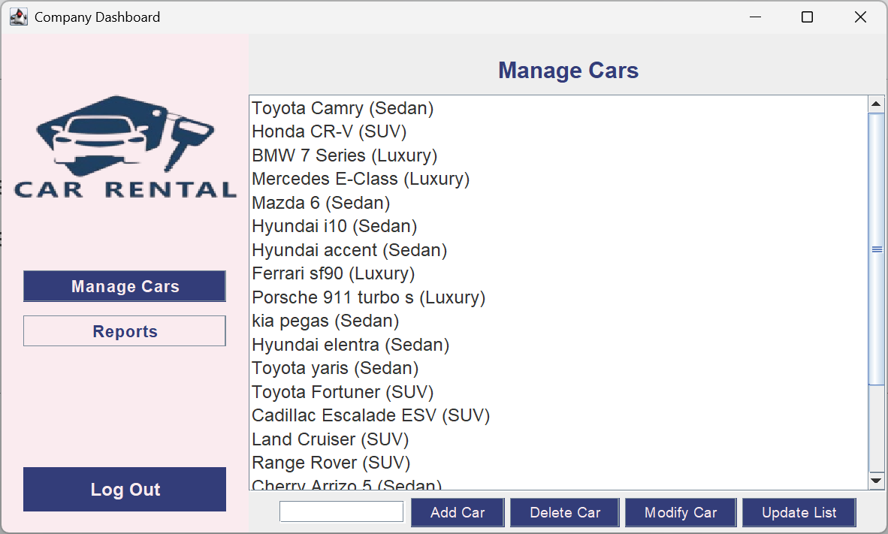

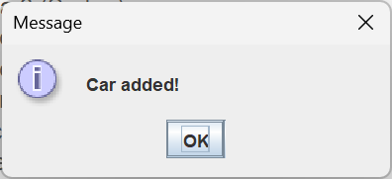
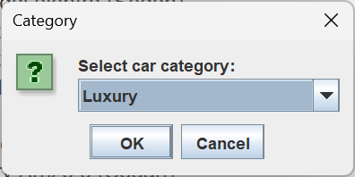

Add Car screenshots:

Modify Car screenshots:

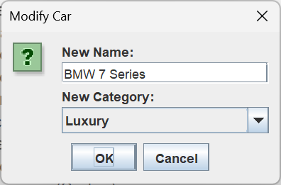
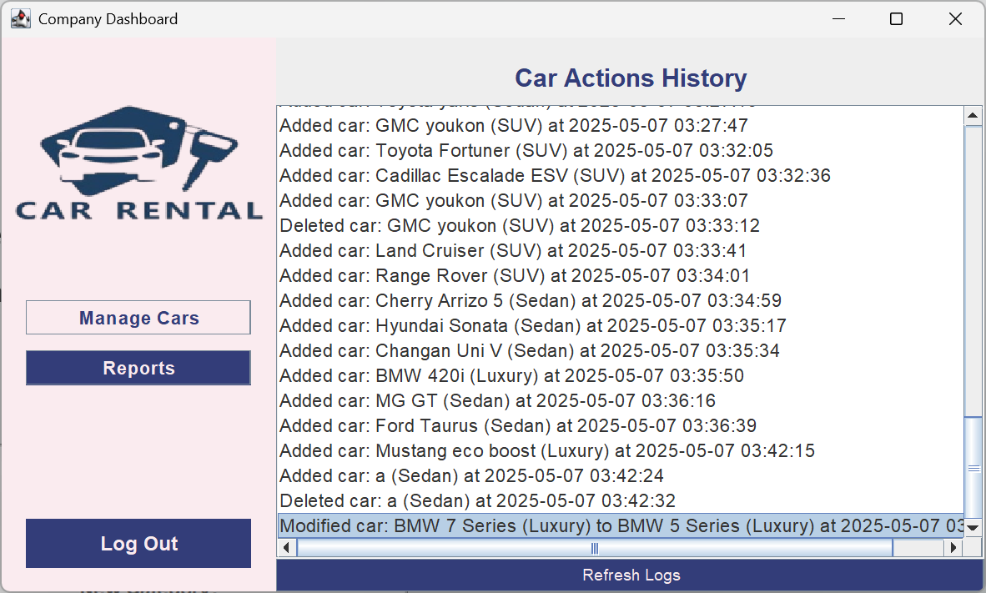

Notice that the modification shows on the log specifying which car properties changed

Modify Car screenshots:

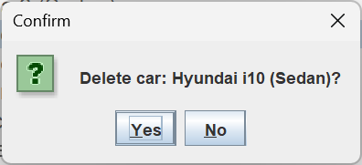
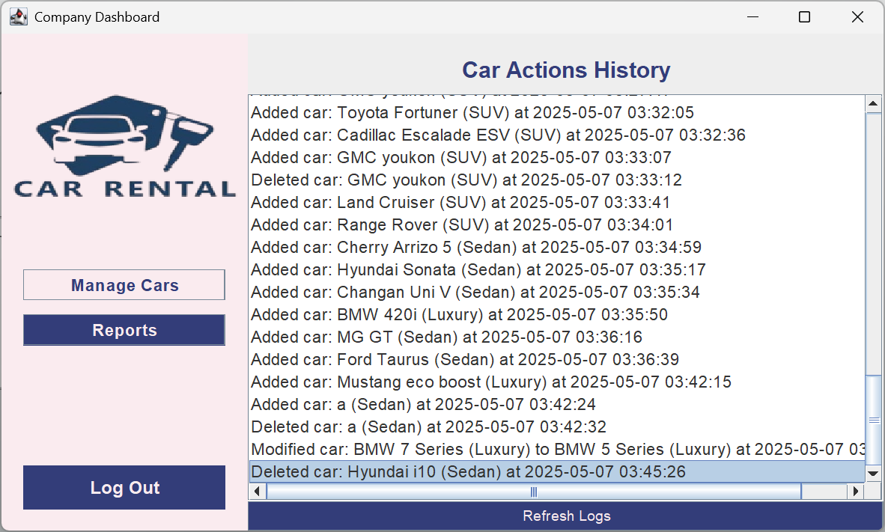

Report log screenshots:

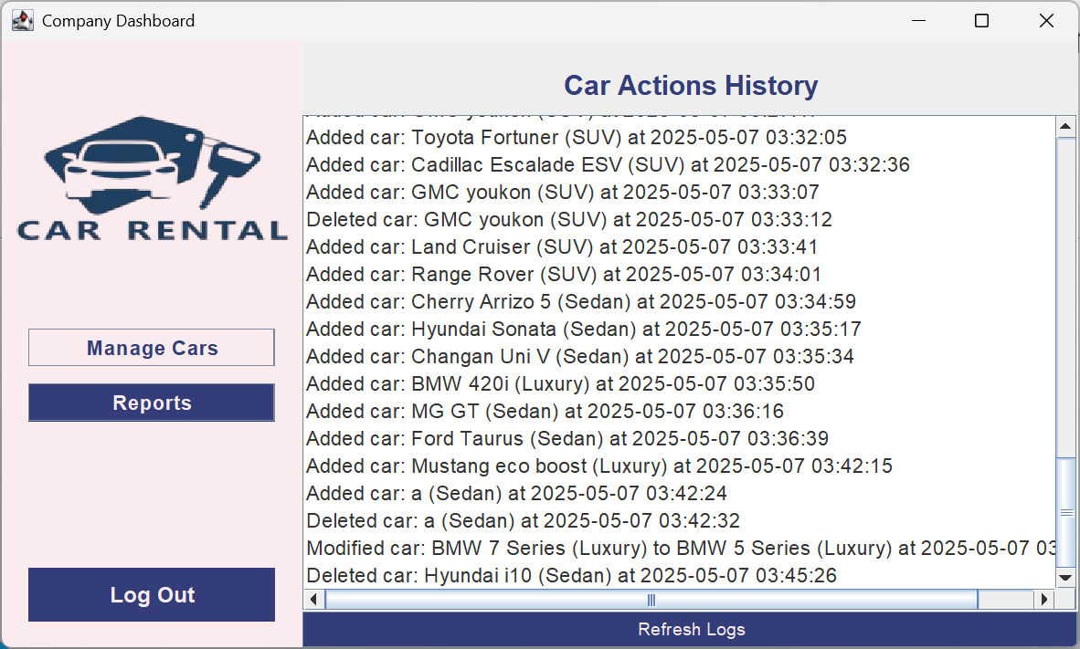

6. Customer Dashboard
- Description: Accessible by customer users after login.
- Features:
  - Browse available cars.
  - Filter cars by type/category.
  - Book/rent a car.
  - View rental history.
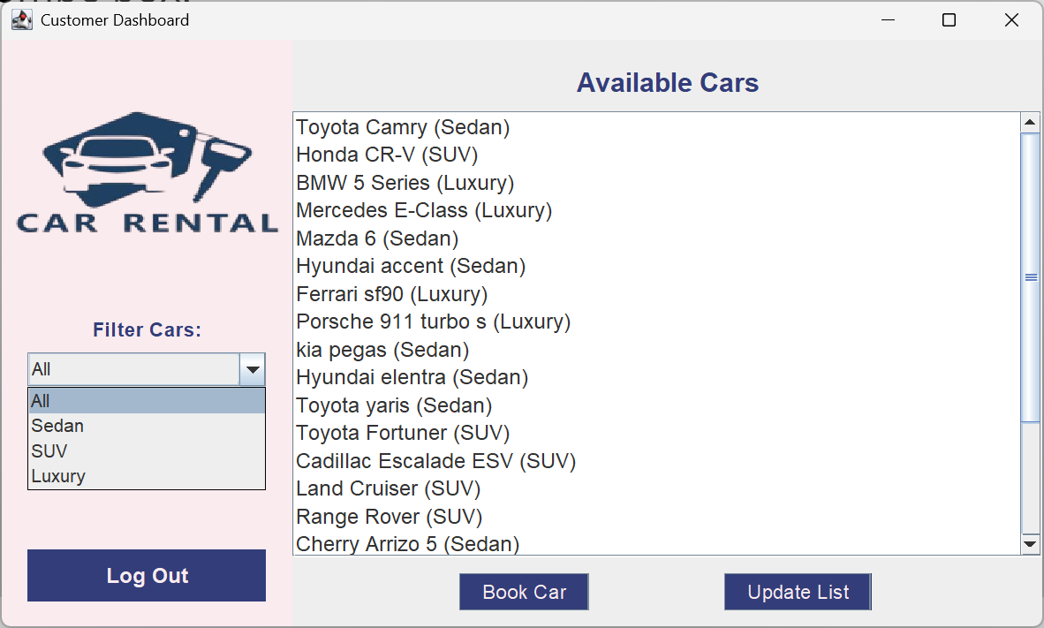

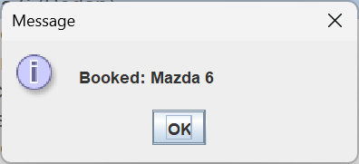

Attachment:

1.source code

import java.awt.*;
import java.util.List;
import javax.swing.*;

public class CarRentalSystem {
public static void main(String[] args) {
new LoginFrame().setVisible(true);
}
}

class LoginFrame extends JFrame {
private JPanel rightPanel;
private CardLayout rightCardLayout;
private JTextField loginUserField, registerUserField;
private JPasswordField loginPassField, registerPassField;

public LoginFrame() {
setTitle("Car Rental System - Log In");
setDefaultCloseOperation(JFrame.EXIT_ON_CLOSE);
setSize(720, 400);
setLocationRelativeTo(null);
setResizable(false);

JPanel mainPanel = new JPanel(new BorderLayout());

JPanel leftPanel = new JPanel();
leftPanel.setBackground(new Color(0xFAEBEF));
leftPanel.setPreferredSize(new Dimension(250, 400));
leftPanel.setLayout(new BoxLayout(leftPanel, BoxLayout.Y_AXIS));

try {
ImageIcon icon = new ImageIcon("image.png");
Image img = icon.getImage().getScaledInstance(320, 200, Image.SCALE_SMOOTH);
JLabel logoLabel = new JLabel(new ImageIcon(img));
logoLabel.setAlignmentX(Component.CENTER_ALIGNMENT);
logoLabel.setBorder(BorderFactory.createEmptyBorder(0, 0, 10, 0));
leftPanel.add(logoLabel);
} catch (Exception ex) {}

leftPanel.add(Box.createVerticalGlue());

JButton loginNavBtn = new JButton("Log In");
loginNavBtn.setAlignmentX(Component.CENTER_ALIGNMENT);
loginNavBtn.setBackground(new Color(0x333D79));
loginNavBtn.setForeground(new Color(0xFAEBEF));
loginNavBtn.setFont(new Font("Arial", Font.BOLD, 16));
loginNavBtn.setFocusPainted(false);
loginNavBtn.setMaximumSize(new Dimension(160, 40));
leftPanel.add(loginNavBtn);
leftPanel.add(Box.createRigidArea(new Dimension(0, 15)));

JButton registerNavBtn = new JButton("Register");
registerNavBtn.setAlignmentX(Component.CENTER_ALIGNMENT);
registerNavBtn.setBackground(new Color(0xFAEBEF));
registerNavBtn.setForeground(new Color(0x333D79));
registerNavBtn.setFont(new Font("Arial", Font.PLAIN, 16));
registerNavBtn.setFocusPainted(false);
registerNavBtn.setMaximumSize(new Dimension(160, 40));
leftPanel.add(registerNavBtn);

leftPanel.add(Box.createVerticalGlue());

rightCardLayout = new CardLayout();
rightPanel = new JPanel(rightCardLayout);

JPanel loginPanel = new JPanel(null);
loginPanel.setBackground(new Color(0x333D79));

JLabel adminLabel = new JLabel("User Log In");
adminLabel.setForeground(new Color(0xFAEBEF));
adminLabel.setFont(new Font("Arial", Font.BOLD, 22));
adminLabel.setBounds(80, 30, 300, 30);
loginPanel.add(adminLabel);

JLabel userLabel = new JLabel("Username");
userLabel.setForeground(new Color(0xFAEBEF));
userLabel.setFont(new Font("Arial", Font.PLAIN, 14));
userLabel.setBounds(80, 80, 300, 20);
loginPanel.add(userLabel);

loginUserField = new JTextField();
loginUserField.setBounds(80, 105, 320, 30);
loginPanel.add(loginUserField);

JLabel passLabel = new JLabel("Password");
passLabel.setForeground(new Color(0xFAEBEF));
passLabel.setFont(new Font("Arial", Font.PLAIN, 14));
passLabel.setBounds(80, 145, 300, 20);
loginPanel.add(passLabel);

loginPassField = new JPasswordField();
loginPassField.setBounds(80, 170, 320, 30);
loginPanel.add(loginPassField);

JButton loginBtn = new JButton("Log In");
loginBtn.setBackground(new Color(0x333D79));
loginBtn.setForeground(new Color(0xFAEBEF));
loginBtn.setFont(new Font("Arial", Font.BOLD, 16));
loginBtn.setFocusPainted(false);
loginBtn.setBounds(80, 220, 320, 38);
loginPanel.add(loginBtn);

JLabel registerHint = new JLabel("Do you have an account? Register");
registerHint.setForeground(new Color(0xFAEBEF));
registerHint.setFont(new Font("Arial", Font.PLAIN, 13));
registerHint.setBounds(120, 285, 250, 25);
loginPanel.add(registerHint);

JPanel registerPanel = new JPanel(null);
registerPanel.setBackground(new Color(0x333D79));

JLabel registerTitle = new JLabel("Register New Account");
registerTitle.setForeground(new Color(0xFAEBEF));
registerTitle.setFont(new Font("Arial", Font.BOLD, 22));
registerTitle.setBounds(80, 30, 350, 30);
registerPanel.add(registerTitle);

JLabel regUserLabel = new JLabel("Username");
regUserLabel.setForeground(new Color(0xFAEBEF));
regUserLabel.setFont(new Font("Arial", Font.PLAIN, 14));
regUserLabel.setBounds(80, 80, 300, 20);
registerPanel.add(regUserLabel);

registerUserField = new JTextField();
registerUserField.setBounds(80, 105, 320, 30);
registerPanel.add(registerUserField);

JLabel regPassLabel = new JLabel("Password");
regPassLabel.setForeground(new Color(0xFAEBEF));
regPassLabel.setFont(new Font("Arial", Font.PLAIN, 14));
regPassLabel.setBounds(80, 145, 300, 20);
registerPanel.add(regPassLabel);

registerPassField = new JPasswordField();
registerPassField.setBounds(80, 170, 320, 30);
registerPanel.add(registerPassField);

JButton registerBtn = new JButton("Register");
registerBtn.setBackground(new Color(0x333D79));
registerBtn.setForeground(new Color(0xFAEBEF));
registerBtn.setFont(new Font("Arial", Font.BOLD, 16));
registerBtn.setFocusPainted(false);
registerBtn.setBounds(80, 220, 320, 38);
registerPanel.add(registerBtn);

JLabel loginHint = new JLabel("Already have an account? Log In");
loginHint.setForeground(new Color(0xFAEBEF));
loginHint.setFont(new Font("Arial", Font.PLAIN, 13));
loginHint.setBounds(120, 285, 250, 25);
registerPanel.add(loginHint);

rightPanel.add(loginPanel, "login");
rightPanel.add(registerPanel, "register");
rightCardLayout.show(rightPanel, "login");

registerNavBtn.addActionListener(e -> rightCardLayout.show(rightPanel, "register"));
registerHint.addMouseListener(new java.awt.event.MouseAdapter() {
public void mouseClicked(java.awt.event.MouseEvent evt) {
rightCardLayout.show(rightPanel, "register");
}
});

loginNavBtn.addActionListener(e -> rightCardLayout.show(rightPanel, "login"));
loginHint.addMouseListener(new java.awt.event.MouseAdapter() {
public void mouseClicked(java.awt.event.MouseEvent evt) {
rightCardLayout.show(rightPanel, "login");
}
});

loginBtn.addActionListener(e -> {
String user = loginUserField.getText().trim();
String pass = new String(loginPassField.getPassword());
if (user.equals("admin") && pass.equals("admin123")) {
LogDAO.log("Log in: admin");
new AdminFrame().setVisible(true);
dispose();
} else if (user.equals("company") && pass.equals("company123")) {
LogDAO.log("Log in: company");
new CompanyFrame().setVisible(true);
dispose();
} else if (CustomerDAO.authenticate(user, pass)) {
LogDAO.log("Log in: " + user);
new CustomerFrame(user).setVisible(true);
dispose();
} else {
JOptionPane.showMessageDialog(this, "Invalid login");
}
});

registerBtn.addActionListener(e -> {
String newUser = registerUserField.getText().trim();
String newPass = new String(registerPassField.getPassword()).trim();
if (newUser.isEmpty() || newPass.isEmpty()) {
JOptionPane.showMessageDialog(this, "Fields cannot be empty!");
} else if (!CustomerDAO.register(newUser, newPass)) {
JOptionPane.showMessageDialog(this, "Username already exists!");
} else {
LogDAO.log("Sign up: " + newUser);
JOptionPane.showMessageDialog(this, "Sign up successful! You can now log in.");
rightCardLayout.show(rightPanel, "login");
}
});

mainPanel.add(leftPanel, BorderLayout.WEST);
mainPanel.add(rightPanel, BorderLayout.CENTER);
setContentPane(mainPanel);
}
}

class AdminFrame extends JFrame {
private DefaultListModel<String> customerListModel = new DefaultListModel<>();
private JList<String> customerList = new JList<>(customerListModel);

private DefaultListModel<String> logListModel = new DefaultListModel<>();
private JList<String> logList = new JList<>(logListModel);

public AdminFrame() {
setTitle("Admin Dashboard");
setSize(600, 450);
setDefaultCloseOperation(JFrame.EXIT_ON_CLOSE);
setLocationRelativeTo(null);
setResizable(false);

JTabbedPane tabs = new JTabbedPane();

JPanel managePanel = new JPanel(new BorderLayout());

refreshCustomerList();
managePanel.add(new JScrollPane(customerList), BorderLayout.CENTER);

JPanel buttonPanel = new JPanel();

JButton addBtn = new JButton("Add Customer");
JButton deleteBtn = new JButton("Delete Customer");
JButton modifyBtn = new JButton("Modify Customer");

for (JButton b : new JButton[]{addBtn, deleteBtn, modifyBtn}) {
b.setBackground(new Color(0x333D79));
b.setForeground(new Color(0xFAEBEF));
b.setFont(new Font("Arial", Font.PLAIN, 13));
b.setFocusPainted(false);
}

addBtn.addActionListener(e -> {
JTextField userField = new JTextField(12);
JTextField passField = new JTextField(12);
Object[] msg = {"Username:", userField, "Password:", passField};
int opt = JOptionPane.showConfirmDialog(this, msg, "Add Customer", JOptionPane.OK_CANCEL_OPTION);
if (opt == JOptionPane.OK_OPTION) {
String u = userField.getText().trim();
String p = passField.getText().trim();
if (!u.isEmpty() && !p.isEmpty()) {
if (!CustomerDAO.register(u, p)) {
JOptionPane.showMessageDialog(this, "Username already exists!");
} else {
LogDAO.log("Admin added customer: " + u);
refreshCustomerList();
}
}
}
});

deleteBtn.addActionListener(e -> {
String selected = customerList.getSelectedValue();
if (selected != null) {
int confirm = JOptionPane.showConfirmDialog(this, "Delete customer: " + selected + "?", "Confirm", JOptionPane.YES_NO_OPTION);
if (confirm == JOptionPane.YES_OPTION) {
CustomerDAO.deleteCustomer(selected);
LogDAO.log("Admin deleted customer: " + selected);
refreshCustomerList();
}
}
});

modifyBtn.addActionListener(e -> {
String selected = customerList.getSelectedValue();
if (selected != null) {
JTextField passField = new JTextField(12);
Object[] msg = {"New Password for " + selected + ":", passField};
int opt = JOptionPane.showConfirmDialog(this, msg, "Modify Customer", JOptionPane.OK_CANCEL_OPTION);
if (opt == JOptionPane.OK_OPTION) {
String newPass = passField.getText().trim();
if (!newPass.isEmpty()) {
CustomerDAO.updatePassword(selected, newPass);
LogDAO.log("Admin modified customer: " + selected);
refreshCustomerList();
}
}
}
});

buttonPanel.add(addBtn);
buttonPanel.add(deleteBtn);
buttonPanel.add(modifyBtn);

managePanel.add(buttonPanel, BorderLayout.SOUTH);

JLabel manageLabel = new JLabel("Manage Users and Cars", SwingConstants.CENTER);
manageLabel.setFont(new Font("Arial", Font.BOLD, 20));
manageLabel.setForeground(new Color(0x333D79));
manageLabel.setBorder(BorderFactory.createEmptyBorder(20, 0, 10, 0));
managePanel.add(manageLabel, BorderLayout.NORTH);

tabs.addTab("Manage", managePanel);

JPanel reportsPanel = new JPanel(new BorderLayout());
JLabel reportsLabel = new JLabel("Sign up, Log in, Log out History", SwingConstants.CENTER);
reportsLabel.setFont(new Font("Arial", Font.BOLD, 20));
reportsLabel.setForeground(new Color(0x333D79));
reportsLabel.setBorder(BorderFactory.createEmptyBorder(20, 0, 10, 0));
reportsPanel.add(reportsLabel, BorderLayout.NORTH);
refreshLogList();
logList.setFont(new Font("Arial", Font.PLAIN, 15));
reportsPanel.add(new JScrollPane(logList), BorderLayout.CENTER);

JButton refreshLogBtn = new JButton("Refresh Logs");
refreshLogBtn.setBackground(new Color(0x333D79));
refreshLogBtn.setForeground(new Color(0xFAEBEF));
refreshLogBtn.setFont(new Font("Arial", Font.PLAIN, 13));
refreshLogBtn.setFocusPainted(false);
reportsPanel.add(refreshLogBtn, BorderLayout.SOUTH);
refreshLogBtn.addActionListener(e -> refreshLogList());

tabs.addTab("Reports", reportsPanel);

JButton logoutBtn = new JButton("Log Out");
logoutBtn.setBackground(new Color(0x333D79));
logoutBtn.setForeground(new Color(0xFAEBEF));
logoutBtn.setFont(new Font("Arial", Font.BOLD, 16));
logoutBtn.setFocusPainted(false);
logoutBtn.addActionListener(e -> {
LogDAO.log("Log out: admin");
dispose();
new LoginFrame().setVisible(true);
});

JPanel mainPanel = new JPanel(new BorderLayout());
mainPanel.add(tabs, BorderLayout.CENTER);
mainPanel.add(logoutBtn, BorderLayout.SOUTH);

setContentPane(mainPanel);
}

private void refreshCustomerList() {
customerListModel.clear();
for (String user : CustomerDAO.getAllCustomers()) {
customerListModel.addElement(user);
}
}

private void refreshLogList() {
logListModel.clear();
for (String entry : LogDAO.getAllLogs()) {
logListModel.addElement(entry);
}
}
}

class CompanyFrame extends JFrame {
private DefaultListModel<String> carListModel = new DefaultListModel<>();
private JList<String> carList = new JList<>(carListModel);

private DefaultListModel<String> logListModel = new DefaultListModel<>();
private JList<String> logList = new JList<>(logListModel);

public CompanyFrame() {
setTitle("Company Dashboard");
setDefaultCloseOperation(JFrame.EXIT_ON_CLOSE);
setSize(800, 480);
setLocationRelativeTo(null);
setResizable(false);

JPanel mainPanel = new JPanel(new BorderLayout());

JPanel leftPanel = new JPanel();
leftPanel.setBackground(new Color(0xFAEBEF));
leftPanel.setPreferredSize(new Dimension(220, 480));
leftPanel.setLayout(new BoxLayout(leftPanel, BoxLayout.Y_AXIS));

try {
ImageIcon icon = new ImageIcon("image.png");
Image img = icon.getImage().getScaledInstance(320, 200, Image.SCALE_SMOOTH);
JLabel logoLabel = new JLabel(new ImageIcon(img));
logoLabel.setAlignmentX(Component.CENTER_ALIGNMENT);
logoLabel.setBorder(BorderFactory.createEmptyBorder(0, 0, 10, 0));
leftPanel.add(logoLabel);
} catch (Exception ex) {}

JButton manageBtn = new JButton("Manage Cars");
manageBtn.setBackground(new Color(0x333D79));
manageBtn.setForeground(new Color(0xFAEBEF));
manageBtn.setFont(new Font("Arial", Font.BOLD, 15));
manageBtn.setFocusPainted(false);
manageBtn.setMaximumSize(new Dimension(180, 36));
manageBtn.setAlignmentX(Component.CENTER_ALIGNMENT);

leftPanel.add(manageBtn);
leftPanel.add(Box.createRigidArea(new Dimension(0, 12)));

JButton reportsBtn = new JButton("Reports");
reportsBtn.setBackground(new Color(0xFAEBEF));
reportsBtn.setForeground(new Color(0x333D79));
reportsBtn.setFont(new Font("Arial", Font.BOLD, 15));
reportsBtn.setFocusPainted(false);
reportsBtn.setMaximumSize(new Dimension(180, 36));
reportsBtn.setAlignmentX(Component.CENTER_ALIGNMENT);

leftPanel.add(reportsBtn);
leftPanel.add(Box.createVerticalGlue());

JButton logoutBtn = new JButton("Log Out");
logoutBtn.setBackground(new Color(0x333D79));
logoutBtn.setForeground(new Color(0xFAEBEF));
logoutBtn.setFont(new Font("Arial", Font.BOLD, 16));
logoutBtn.setFocusPainted(false);
logoutBtn.setAlignmentX(Component.CENTER_ALIGNMENT);
logoutBtn.setMaximumSize(new Dimension(180, 36));
logoutBtn.setBorder(BorderFactory.createEmptyBorder(10, 0, 10, 0));
leftPanel.add(logoutBtn);
leftPanel.add(Box.createRigidArea(new Dimension(0, 18)));
logoutBtn.addActionListener(e -> {
LogDAO.log("Log out: company");
dispose();
new LoginFrame().setVisible(true);
});

CardLayout rightCards = new CardLayout();
JPanel rightPanel = new JPanel(rightCards);

JPanel managePanel = new JPanel(new BorderLayout());
JLabel manageLabel = new JLabel("Manage Cars", SwingConstants.CENTER);
manageLabel.setFont(new Font("Arial", Font.BOLD, 20));
manageLabel.setForeground(new Color(0x333D79));
manageLabel.setBorder(BorderFactory.createEmptyBorder(20, 0, 10, 0));
managePanel.add(manageLabel, BorderLayout.NORTH);

refreshCarList();
carList.setFont(new Font("Arial", Font.PLAIN, 16));
managePanel.add(new JScrollPane(carList), BorderLayout.CENTER);

JPanel buttonPanel = new JPanel();
JTextField carField = new JTextField(12);
buttonPanel.add(carField);

JButton addBtn = new JButton("Add Car");
JButton deleteBtn = new JButton("Delete Car");
JButton modifyBtn = new JButton("Modify Car");
JButton updateBtn = new JButton("Update List");

for (JButton b : new JButton[]{addBtn, deleteBtn, modifyBtn, updateBtn}) {
b.setBackground(new Color(0x333D79));
b.setForeground(new Color(0xFAEBEF));
b.setFont(new Font("Arial", Font.PLAIN, 13));
b.setFocusPainted(false);
}

buttonPanel.add(addBtn);
buttonPanel.add(deleteBtn);
buttonPanel.add(modifyBtn);
buttonPanel.add(updateBtn);

managePanel.add(buttonPanel, BorderLayout.SOUTH);

addBtn.addActionListener(e -> {
String carName = carField.getText().trim();
if (!carName.isEmpty()) {
String[] categories = {"Sedan", "SUV", "Luxury"};
String category = (String) JOptionPane.showInputDialog(this, "Select car category:", "Category",
JOptionPane.QUESTION_MESSAGE, null, categories, categories[0]);
if (category != null) {
CarDAO.addCar(carName, category);
LogDAO.log("Added car: " + carName + " (" + category + ")");
carField.setText("");
JOptionPane.showMessageDialog(this, "Car added!");
refreshCarList();
}
}
});
deleteBtn.addActionListener(e -> {
String selected = carList.getSelectedValue();
if (selected != null) {
String name = selected.split("\\(")[0].trim();
String category = selected.substring(selected.indexOf("(") + 1, selected.indexOf(")"));
int confirm = JOptionPane.showConfirmDialog(this, "Delete car: " + selected + "?", "Confirm", JOptionPane.YES_NO_OPTION);
if (confirm == JOptionPane.YES_OPTION) {
CarDAO.deleteCar(name, category);
LogDAO.log("Deleted car: " + selected);
refreshCarList();
}
}
});
modifyBtn.addActionListener(e -> {
String selected = carList.getSelectedValue();
if (selected != null) {
String oldName = selected.split("\\(")[0].trim();
String oldCategory = selected.substring(selected.indexOf("(") + 1, selected.indexOf(")"));
JTextField newCarField = new JTextField(oldName, 12);
String[] categories = {"Sedan", "SUV", "Luxury"};
JComboBox<String> categoryBox = new JComboBox<>(categories);
categoryBox.setSelectedItem(oldCategory);
Object[] msg = {"New Name:", newCarField, "New Category:", categoryBox};
int opt = JOptionPane.showConfirmDialog(this, msg, "Modify Car", JOptionPane.OK_CANCEL_OPTION);
if (opt == JOptionPane.OK_OPTION) {
String newName = newCarField.getText().trim();
String newCat = (String) categoryBox.getSelectedItem();
if (!newName.isEmpty()) {
CarDAO.updateCar(oldName, oldCategory, newName, newCat);
LogDAO.log("Modified car: " + selected + " to " + newName + " (" + newCat + ")");
refreshCarList();
}
}
}
});
updateBtn.addActionListener(e -> refreshCarList());

JPanel reportsPanel = new JPanel(new BorderLayout());
JLabel reportsLabel = new JLabel("Car Actions History", SwingConstants.CENTER);
reportsLabel.setFont(new Font("Arial", Font.BOLD, 20));
reportsLabel.setForeground(new Color(0x333D79));
reportsLabel.setBorder(BorderFactory.createEmptyBorder(20, 0, 10, 0));
reportsPanel.add(reportsLabel, BorderLayout.NORTH);

refreshLogList();
logList.setFont(new Font("Arial", Font.PLAIN, 15));
reportsPanel.add(new JScrollPane(logList), BorderLayout.CENTER);

JButton refreshLogBtn = new JButton("Refresh Logs");
refreshLogBtn.setBackground(new Color(0x333D79));
refreshLogBtn.setForeground(new Color(0xFAEBEF));
refreshLogBtn.setFont(new Font("Arial", Font.PLAIN, 13));
refreshLogBtn.setFocusPainted(false);
reportsPanel.add(refreshLogBtn, BorderLayout.SOUTH);
refreshLogBtn.addActionListener(e -> refreshLogList());

rightPanel.add(managePanel, "manage");
rightPanel.add(reportsPanel, "reports");
rightCards.show(rightPanel, "manage");

manageBtn.addActionListener(e -> {
manageBtn.setBackground(new Color(0x333D79));
manageBtn.setForeground(new Color(0xFAEBEF));
reportsBtn.setBackground(new Color(0xFAEBEF));
reportsBtn.setForeground(new Color(0x333D79));
rightCards.show(rightPanel, "manage");
});
reportsBtn.addActionListener(e -> {
reportsBtn.setBackground(new Color(0x333D79));
reportsBtn.setForeground(new Color(0xFAEBEF));
manageBtn.setBackground(new Color(0xFAEBEF));
manageBtn.setForeground(new Color(0x333D79));
rightCards.show(rightPanel, "reports");
});

mainPanel.add(leftPanel, BorderLayout.WEST);
mainPanel.add(rightPanel, BorderLayout.CENTER);

setContentPane(mainPanel);
}

private void refreshCarList() {
carListModel.clear();
for (String car : CarDAO.getAllCars()) {
carListModel.addElement(car);
}
}

private void refreshLogList() {
logListModel.clear();
for (String entry : LogDAO.getAllLogs()) {
logListModel.addElement(entry);
}
}
}

class CustomerFrame extends JFrame {
private DefaultListModel<String> carListModel = new DefaultListModel<>();
private JList<String> carList = new JList<>(carListModel);
private JComboBox<String> typeCombo;
private String username;

public CustomerFrame(String username) {
this.username = username;
setTitle("Customer Dashboard");
setSize(800, 480);
setDefaultCloseOperation(JFrame.EXIT_ON_CLOSE);
setLocationRelativeTo(null);

JPanel mainPanel = new JPanel(new BorderLayout());

JPanel leftPanel = new JPanel();
leftPanel.setBackground(new Color(0xFAEBEF));
leftPanel.setPreferredSize(new Dimension(220, 480));
leftPanel.setLayout(new BoxLayout(leftPanel, BoxLayout.Y_AXIS));

try {
ImageIcon icon = new ImageIcon("image.png");
Image img = icon.getImage().getScaledInstance(320, 200, Image.SCALE_SMOOTH);
JLabel logoLabel = new JLabel(new ImageIcon(img));
logoLabel.setAlignmentX(Component.CENTER_ALIGNMENT);
logoLabel.setBorder(BorderFactory.createEmptyBorder(0, 0, 10, 0));
leftPanel.add(logoLabel);
} catch (Exception ex) {}

JLabel filterLabel = new JLabel("Filter Cars:");
filterLabel.setFont(new Font("Arial", Font.BOLD, 15));
filterLabel.setForeground(new Color(0x333D79));
filterLabel.setAlignmentX(Component.CENTER_ALIGNMENT);
leftPanel.add(filterLabel);
leftPanel.add(Box.createRigidArea(new Dimension(0, 8)));

typeCombo = new JComboBox<>(new String[]{"All", "Sedan", "SUV", "Luxury"});
typeCombo.setMaximumSize(new Dimension(180, 30));
typeCombo.setFont(new Font("Arial", Font.PLAIN, 14));
typeCombo.setAlignmentX(Component.CENTER_ALIGNMENT);
leftPanel.add(typeCombo);

leftPanel.add(Box.createVerticalGlue());

JButton logoutBtn = new JButton("Log Out");
logoutBtn.setBackground(new Color(0x333D79));
logoutBtn.setForeground(new Color(0xFAEBEF));
logoutBtn.setFont(new Font("Arial", Font.BOLD, 16));
logoutBtn.setFocusPainted(false);
logoutBtn.setAlignmentX(Component.CENTER_ALIGNMENT);
logoutBtn.setMaximumSize(new Dimension(180, 36));
logoutBtn.setBorder(BorderFactory.createEmptyBorder(10, 0, 10, 0));
leftPanel.add(logoutBtn);
leftPanel.add(Box.createRigidArea(new Dimension(0, 18)));

JPanel rightPanel = new JPanel(new BorderLayout());

JLabel carListLabel = new JLabel("Available Cars", SwingConstants.CENTER);
carListLabel.setFont(new Font("Arial", Font.BOLD, 20));
carListLabel.setForeground(new Color(0x333D79));
carListLabel.setBorder(BorderFactory.createEmptyBorder(20, 0, 10, 0));
rightPanel.add(carListLabel, BorderLayout.NORTH);

carList.setFont(new Font("Arial", Font.PLAIN, 16));
rightPanel.add(new JScrollPane(carList), BorderLayout.CENTER);

JPanel buttonPanel = new JPanel();
buttonPanel.setLayout(new BoxLayout(buttonPanel, BoxLayout.X_AXIS));
buttonPanel.setBorder(BorderFactory.createEmptyBorder(12, 24, 12, 24));

JButton bookBtn = new JButton("Book Car");
JButton updateBtn = new JButton("Update List");

for (JButton b : new JButton[]{bookBtn, updateBtn}) {
b.setBackground(new Color(0x333D79));
b.setForeground(new Color(0xFAEBEF));
b.setFont(new Font("Arial", Font.PLAIN, 15));
b.setFocusPainted(false);
b.setMaximumSize(new Dimension(180, 36));
b.setAlignmentX(Component.CENTER_ALIGNMENT);
buttonPanel.add(Box.createHorizontalGlue());
buttonPanel.add(b);
}
buttonPanel.add(Box.createHorizontalGlue());

rightPanel.add(buttonPanel, BorderLayout.SOUTH);

typeCombo.addActionListener(e -> filterCars((String)typeCombo.getSelectedItem()));

bookBtn.addActionListener(e -> {
String selected = carList.getSelectedValue();
if (selected != null) {
String carName = selected.split("\\(")[0].trim();
JOptionPane.showMessageDialog(this, "Booked: " + carName);
LogDAO.log("Booked: " + carName + " by " + username);
}
});

updateBtn.addActionListener(e -> filterCars((String)typeCombo.getSelectedItem()));

logoutBtn.addActionListener(e -> {
LogDAO.log("Log out: " + username);
dispose();
new LoginFrame().setVisible(true);
});

mainPanel.add(leftPanel, BorderLayout.WEST);
mainPanel.add(rightPanel, BorderLayout.CENTER);

setContentPane(mainPanel);

filterCars("All");
}

private void filterCars(String type) {
carListModel.clear();
List<String> allCars = CarDAO.getAllCars();
for (String car : allCars) {
if (type.equals("All") || car.contains("(" + type + ")")) {
carListModel.addElement(car);
}
}
}
}

